**LabVIEW 101 – Weeks 7**

Before class:

1. Download updates from <https://github.com/rizett/LabVIEW-101>

Required equipment:

Computer with LV installed

Topics:

Review last term – go over exercise from week 6

Overview of what we’ll learn this term – term project?

Introduction to wiring

**Review last term:**

* Review / go through week6_exercise4.vi from the last week of the previous term

**Overview of upcoming classes:**

Introduction to wiring and electronic components

Reading analog signal using NI-USB / DAQ

Sending analog signal using NI-USB / DAQ

Reading from serial devices

Writing to serial devices

Errors: common errors, runtime errors, error handling, troubleshooting

AutoIt & System Commands

Synthesizing everything; saving to runtime and LV projects

Class projects

**Introduction to wiring:**

1. Different power sources
   1. DC wall adapters:
      1. Cutting
      2. ID +/- (voltmeter) (one is usually striped)
   2. AC Wall plugs / cables:
      1. Cutting
      2. ID L/N (ohmmeter – avoid checking voltage / current when plugged in
   3. Salvaging parts from e-waste – field trip!
   4. Good practices:
      1. Stick to a consistent colour convection
      2. LABEL wires!
   5. Big power supply (e.g. on MIMS) vs smaller power supply (in PIGI)
      1. Load limits
      2. Sharing terminals
   6. Splicing wires
      1. Quick (dis)-connects
      2. Soldering – remember to put the sleeve on FIRST!
      3. Can link multiple wires – as long as the current load is not exceeded, and the polarity is consistent
2. Wires in different devices:
   1. Serial = 4 main wires:
      1. + / - DC, TX, RX
      2. ID using ohmmeter
      3. Can be cut to reveal 9 wires inside (or more): note how to count them

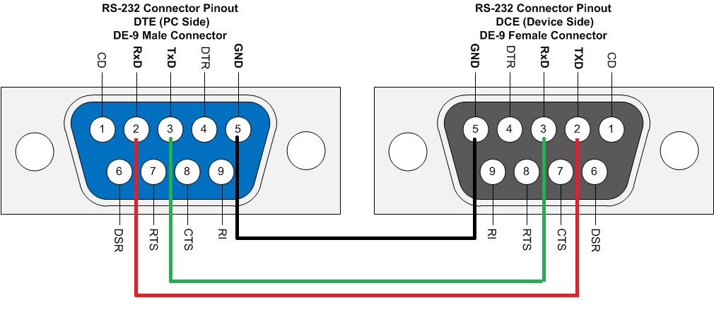

Male Female

* 1. USB has the same 4 wires!
     1. USB to serial
     2. USB is also a source of 5VDC

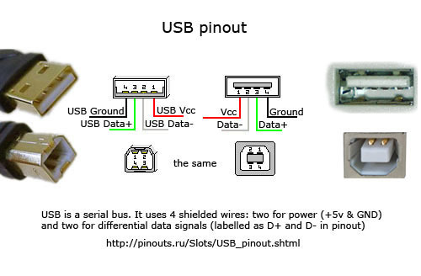

1. Introduction to other devices we’ll use
   1. Relays:
      1. How they work – use a diagram
      2. Inputs and outputs
   2. NI DAQ:
      1. Analog (continuous) input and output
         1. Read thermocouples, paddlewheel
         2. Control relays to control pump, fan, solenoid valve.
      2. Digital (discrete / square waves)
   3. Serial devices:
      1. Optode / GTD: open wires
      2. MIMS valves: DB9 cables
      3. Many of the instruments in the lab will be Serial – and they will have a set of basic commands
         1. E.g. MIMS, Winkler pump/meter etc.

